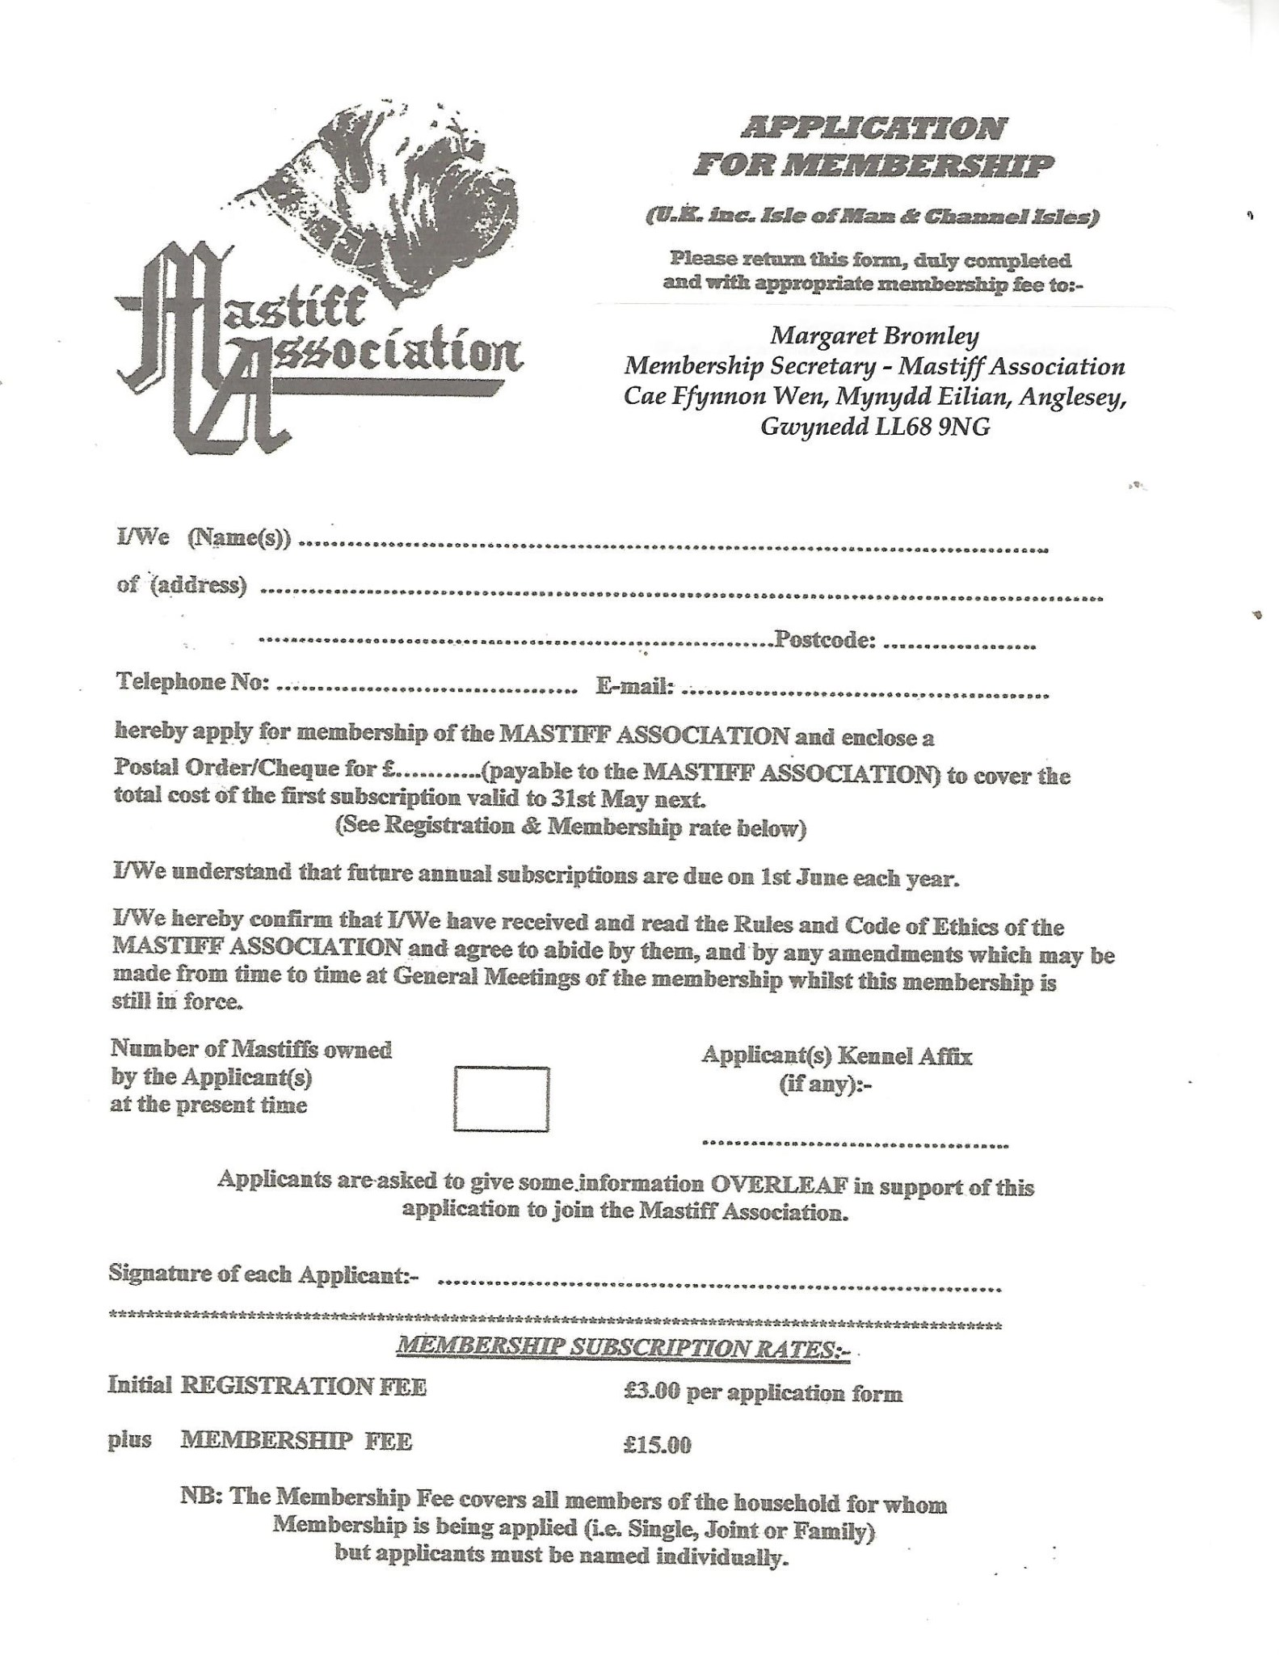

**Bigbury House”, 9 Perry’s Lane, Seend Cleeve, Melksham, Wiltshire SN12 6QA**

